**IBM NAAN MUDHALVAN PROJECT**

**PROJECT TITLE: FLOOD MONITARING SYSTEM**

**COLLEGE NAME AND CODE: PERI INSTITUTE OF TECHNOLOGY [4115]**

**DEPT: ELECTRONICS AND COMMUNICATION ENGINEERING**

**DOMAIN: INTERNET OF THINGS (IOT)**

**Submitted By**

**SILAMBARASAN.S -(au411521106052)**

**PHASE-1**

**Abstract:**

Flooding is considered one of the most destructive natural disasters in the world. In countries like India with climatic conditions occurrence of heavy rain fall and subsequent discharge of water leads to Flood. Flooding creates major damages to life, their habitats and the economy By installing of flood alerting systems near major waterways vital information can be provide so that lives and property can be protected. Normal Weather monitoring and alerting systems are not quick and accurate enough to predict floods in time to prevent personal or environmental damages. The government has to spend tons of money in flood mitigation plans to help the victims and also to reduce the number in the long run damages that can occur after flooding. In the present work we have used thingspeak-IOT platform and GSM module. Since Most of the flood alerting systems involves high cost they are deployed on select locations based on priority. In this project we make use of a cost effective system using raspberry pi board and sensors, to measure rise of water level in rivers and water bodies and alert government authorities and people instantly by transmitting information using IOT. In the present work we have used thingspeak-IOT platform and GSM module. The data can be accessed from android smart phones using things View mobile application at anytime from anywhere in the world where GSM module is used to send the alert message to the people. . The government has to spend tons of money in flood mitigation plans to help the victims and also to reduce the number in the long run damages that can occur after flooding.

**Introduction:**

The extreme climatic changes due to the effect from various human activities such as pollutions, cutting of innumerable trees and too much of gas emission are the some of the main reason for natural disasters that occur in worldwide . The most common factor that cause major damage to life, property and country’s economy is the flood .Flooding is brought on by an increased quantity of water in lake or river when it is overflowing. When a dam fractures and abruptly releasing a massive quantity of water not only houses and property are damaged , sewage overflow and chemical spillage also leads to a variety of diseases afterwards. To manage these kind of situations and alert people understanding of increased water level and speed of water flow are valuable for discovering potential seriousness of the flood. This project presents the details of how the data - like flood level and rain intensity are collected from sensors and made available on cloud and sending alert messages by using Raspberry pi , Thingspeak-an IOT platform and a Global System for Mobile communication (GSM) and short message service (SMS) to relay data from sensors to computers or directly alert the People of that area through their mobile phone. The data from the IOT cloud can be accessed by android smart phones at anytime from anywhere in the world using the mobile app things view.

**Project Definition:**

**PROPOSED SYSTEM:**

The proposed flood alerting system to check the flood level basically consists of a Raspberry pi which detects the water level and rain intensity using an Ultrasonic Distance Sensor (HC-SR04) and rain sensor respectively. The ultrasonic distance sensor –which is used to measures the time of travel by echo signal gives the water level of flood in river. The Rain Sensor is used to show the Rain status that it’s raining or not, and its rain intensity Value. The Pi board is also programmed to send the data to a cloud are using an external web server named as Thingspeak so as to alert the general public.By applying an Internet of Thing can help people to monitor the flood water level and rain intensity via thingsview app in smartphone together with the alerting system for incoming flood. A wireless sensor node connected with Raspberry pi is used which consist of ultrasonic sensors and rain sensor to collect data and sent them via cloud to be viewed in Thingsview application. GSM Module is used to send alert SMS to the People When the water level reaches a certain level of hazards, the device will generate an alarm system with three different colours of LEDs indicating three levels of detection for flood level and send Alert notification to the people on incoming flood in that area.

**Objective:**

1. Eliminate or minimize disruption of local government operations caused by flood hazard events.
2. Maintain a regionally coordinated warning and emergency response program that can detect the flood threat and provide timely warning.
3. Utilizing best available data and science, continually improve understanding of the location and potential impacts of flood hazards, the vulnerability of building types and community development patterns, and the measures needed to protect life safety.
4. Continually provide state, county and local agencies with updated information about flood hazards, vulnerabilities and mitigation initiatives.
5. Establish partnerships among all levels of government and the business community to improve and implement regionally consistent floodplain management practices such as prevention, property protection, public education and awareness, natural resource protection, emergency services, and capital improvements.
6. Develop or improve early warning emergency response systems and evacuation procedures for flood hazard events.
7. Work to lower emergency service response times, including through improvement to transportation facilities.
8. Consider the impacts of flood hazards in all planning processes that address current and future land uses within the planning area.
9. Evaluate the risks to public safety and existing development e.g., critical facilities, infrastructure, and structures in flood hazard areas.
10. Sponsor and support public outreach and education activities to improve awareness of flood hazards, and recommend roles that property owners can take to prepare, respond, recover and protect themselves from the impacts of these events.
11. Consider the impacts that future development will have on the environment’s capacity to withstand the impacts of flood events and the opportunities this development may create for environmental restoration.Top of Form

IOT SENSOR DESIGN:

Designing IoT (Internet of Things) sensor systems for a Flood monitoring system project requires careful consideration of the specific needs and objectives of the project. Here's some essential IoT sensors and their design considerations for a Flood Monitoring System:

**SYSTEM ARCHITECTURE:**

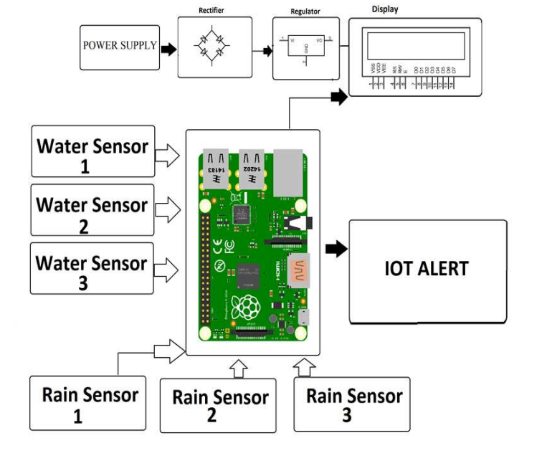

**NEED OF REQUIREMENTS:**

* Arduino UNO(atmega328p)
* Buzzer
* GSM Module
* NodeMCU
* Water Level Sensor
* LED